Unix timestamp

Definition:
# Source: AI Source: Provided by: [Data Path: Persons Table -> ID Column: 1, Name_En Column: Motasem Essam] -> From: [ChatGPT] on [1/26/2026]
A Unix timestamp (also called Unix time or Epoch time) is the number of seconds that have passed since January 1, 1970, 00:00:00 UTC.
This starting point is called the Unix Epoch.

Example

Definition:
# Source: AI Source: Provided by: [Data Path: Persons Table -> ID Column: 1, Name_En Column: Motasem Essam] -> From: [ChatGPT] on [1/26/2026]
- 0 → Jan 1, 1970, 00:00:00 UTC
- 1700000000 → Nov 14, 2023 (UTC)
- 1765444522 → Feb 10, 2026 (UTC)
It’s widely used in:
- Operating systems (Linux, macOS, Android)
- Programming (Python, JavaScript, C, etc.)
- Databases and logs
- APIs and web apps

Why Unix timestamps are useful

Definition:
# Source: AI Source: Provided by: [Data Path: Persons Table -> ID Column: 1, Name_En Column: Motasem Essam] -> From: [ChatGPT] on [1/26/2026]
- Simple number (easy for computers)
- Timezone-independent (always UTC)
- Easy to compare and calculate time differences

Quick examples in code

Definition:
# Source: AI Source: Provided by: [Data Path: Persons Table -> ID Column: 1, Name_En Column: Motasem Essam] -> From: [ChatGPT] on [1/26/2026]
Python
import time
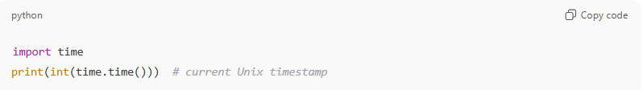
print(int(time.time())) # current Unix timestamp
JavaScript
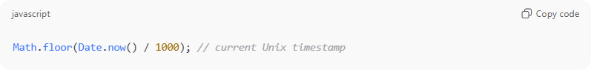
Math.floor(Date.now() / 1000); // current Unix timestamp

